Workshop Documentation Winnie Yoe

**Confrontation for Introverts: Creative Strategies for Sensing and Expressing**

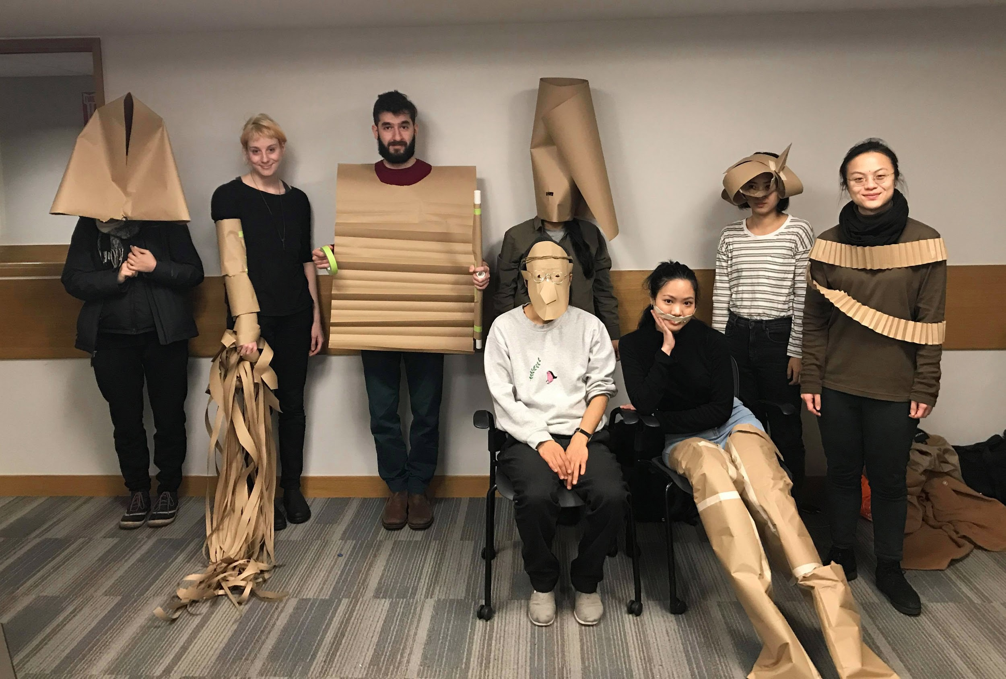

***Introduction***

During my senior year in college, I was asked to create a sculpture as big as my size. Wanting to adhere to my belief that expressive power in art should not correlate with its size and in protest against associations with the monumental, I welded a cocoon-shaped cage and stayed inside in silence until released by an audience. Overtime, the atmosphere changed from playful to confused to uncomfortable while the power dynamic shifted from the audience to me. It was then I realized, sometimes subtle interactions could speak the loudest.

That was a moment that shaped my practice and inspired this workshop. This workshop is for times when words fail to express, occasions when formal channels fail to bring closures, and situations when systems fail to acknowledge. This is a workshop for all anxious introverts who feel strongly.

***Learning Objectives and Outcome***

* Learn about creative and kinesthetic strategies for expressing and sensing
* Use object making to connect body and emotions
* Create new frames of references in understanding our relationship with the body
* Recognize the power in vulnerability and discomfort

***Target Audience***

* Introverts who feel/have felt strongly
* Kinesthetic learners
* Young adults/adults who are interested in creative expression

***Syllabus & Rundown* (50 mins)**

1. **Introduction** (Why this workshop? See Appendix I: Slides for detail) — 5 mins
   1. Explain purpose of the workshop: explore new ways to sense and response to our world. There will not be solutions, but perhaps there will be resolutions towards bringing emotional closures
2. **Warm Up Exercise** — 3 mins in silence
   1. Ask participants to line up in two rows facing each other
   2. Ask participants to turn 180, walk towards the wall as close as they would like
   3. Ask participants to turn 180, walk towards the person opposite them and stop until they are as close as they were to the wall
   4. Repeat b.
   5. Ask one person in the pair picks up a PVC pipe
   6. Ask participants to turn 180, ask those with PVC pipe to hold straight, pointing to the opposite side.
   7. Ask participants to walk towards the middle until the other participant can hold to end of the PVC pipe
   8. Ask the participants to move their hands towards the middle of the pipe without dropping the pipe until their hands almost touch
   9. Ask participants to reach out and shake hands. Nice to meet you
3. **Show references** — 2 mins
   1. Artists:
      1. Ann Hamilton’s *Untitled (body object series, 1984–1993)*
      2. Lygia Clark
      3. Kathleen McDermott
   2. Show examples of appendages created under 30 mins
4. **Create Appendage** — 30 mins

Use everyday material to create an appendage. The emphasis for this exercise is exploring how we can translate emotions/thoughts into physical making, rather than making anything polished. In this workshop, I limit the materials to paper and tape, so that the participants could focus more on their idea, less on materiality.

1. **Sharing + Photograph** (Instant camera) — 10 mins

***Budget***

|  |  |
| --- | --- |
| Material | Price |
| Newsprint | Free from ITP |
| Tape | ~$13.00 |
| PVC pipes | Free from classmates |
| Scissors | Free from ITP |

***Reflection***

The day of the event was the first time that I had run the workshop in a group setting, previously, I have test ran the workshop with two individuals separately to test if the timeframe for making the appendage was feasible. I had worries that the instructions were not clear, as most participants do not come from a studio art background, and I was not sure if I explained the idea of an appendage well enough. I was very impressed by what the participants created in the end of the workshop — the objective for the workshop was to use physical making to express themselves, which I felt was met — participants either created appendages in response to their current environment, or a thought/feeling they have. During the workshop, I showed artists references and samples of what I and other volunteers created in the same timeframe — which I think helped contribute to the success of the workshop. I did feel the ending of the workshop was unresolved — I took photos of the participant with their appendage on an instant camera and gave the image to them as a gift, I also handed out leaflets with examples of other creative strategies in expressing. I did not want to have an immediate debrief because I wanted the participants to have time and space for their thoughts for the workshop to sink in, but I felt that the workshop did ended bit abruptly. It was probably better if I had placed the leaflets on the seats prior to the start of the workshop, and if I had ended with a few thoughtful remarks to wrap the workshop.

After reviewing the feedback, I think it would also be helpful to explain each of the sessions and why we are doing them so that the objective and connections are clear for the participants.

***Feedback***

Methodology: I asked participants how likely they would recommend this workshop to others and why, and also if they have other feedback.

“Thought provoking workshop to discomfort, sculpture and the body. I really enjoyed learning about your practice, relating that practice to other artists to provide a historical context and then having the ability to quickly make my own piece.”

— Feedback 1

“I would recommend the workshop to people who are interested in creative impromptu experiments and curious discovering new areas. From design perspective the workshop was very well thought - the presentation, the leaflets, the Polaroid photos. We were provided soft materials such as papers and threads, however I would like to have more hard materials and skills to work with. I guess workshop participants had enough freedom to create, though I would prefer having a central topic to design the appendages for. I liked the ice-breaking exercise prior the starting workshop, however I didn't see its connection to the overall workshop.”

— Feedback 2

“The warm-up was nice. Though I wish you had more time to explain a little bit more about purpose of the workshop and show more examples.”

— Feedback 3

“I think the workshop was a nice space to spend time to think about what is important to us and how we could show/express that in a non-verbal way. I like that you get to create something that is made only for you but in a way also hint the people around you what kind of person you are.”

— Feedback 4

“WOULD because it is effective in making me evaluate myself and channeling it into something creative. i felt better about my feelings afterwards. WOULDN'T because it felt rushed - especially the part where the facilitator explains the background and concept of the workshop. also it felt like they could do it themselves at home.”

**Appendix I: Slides**

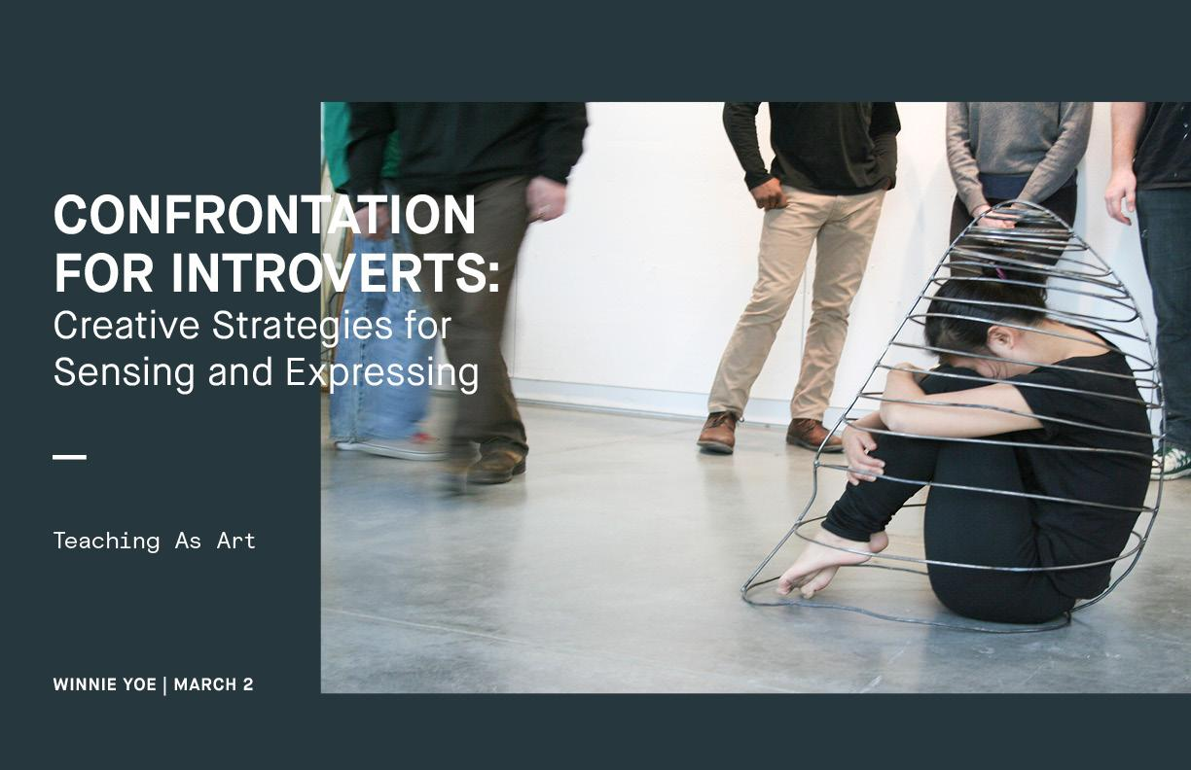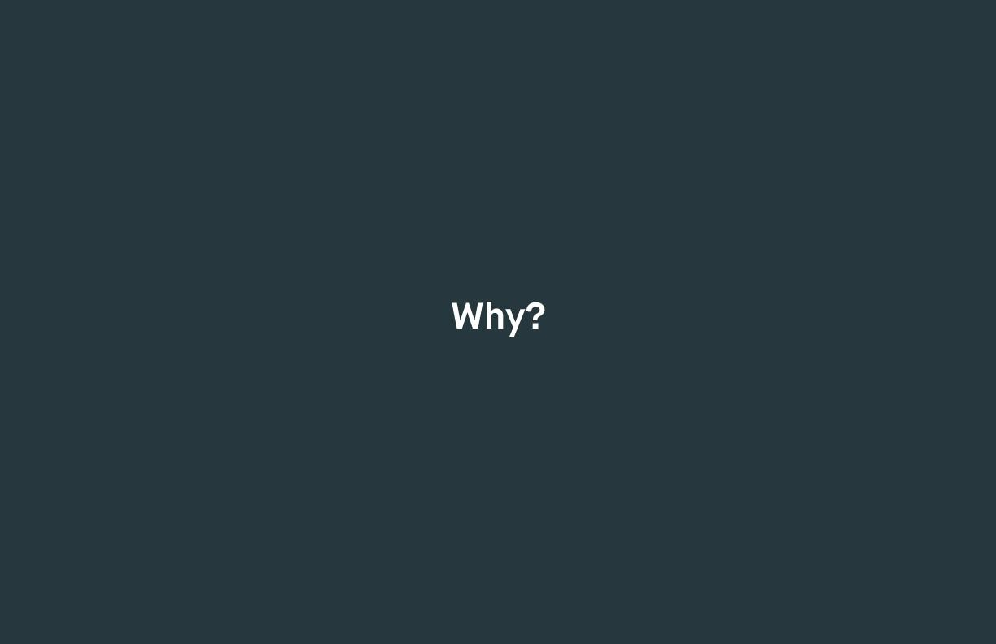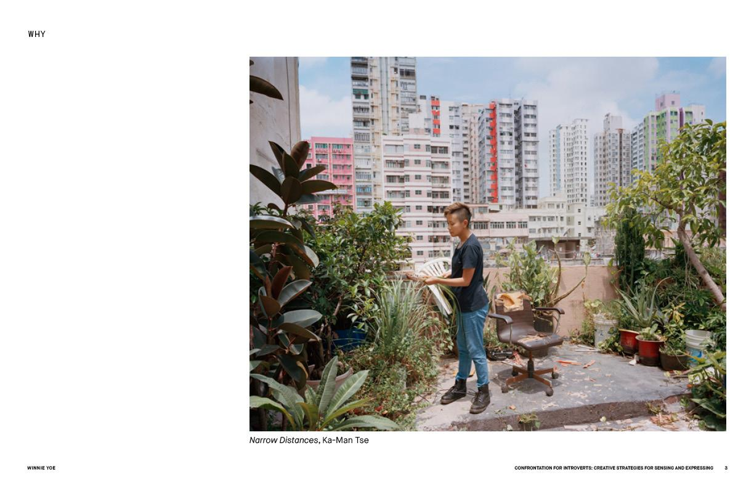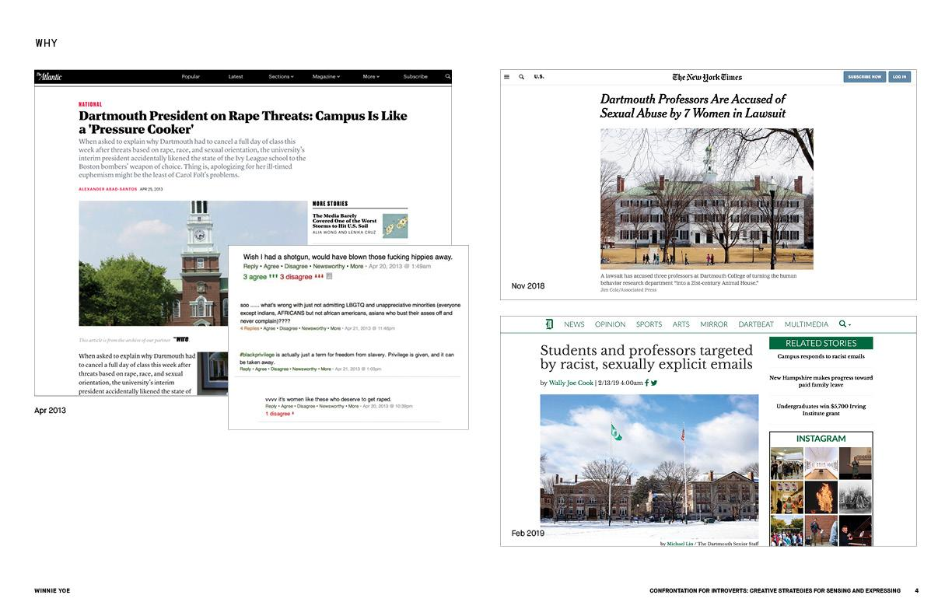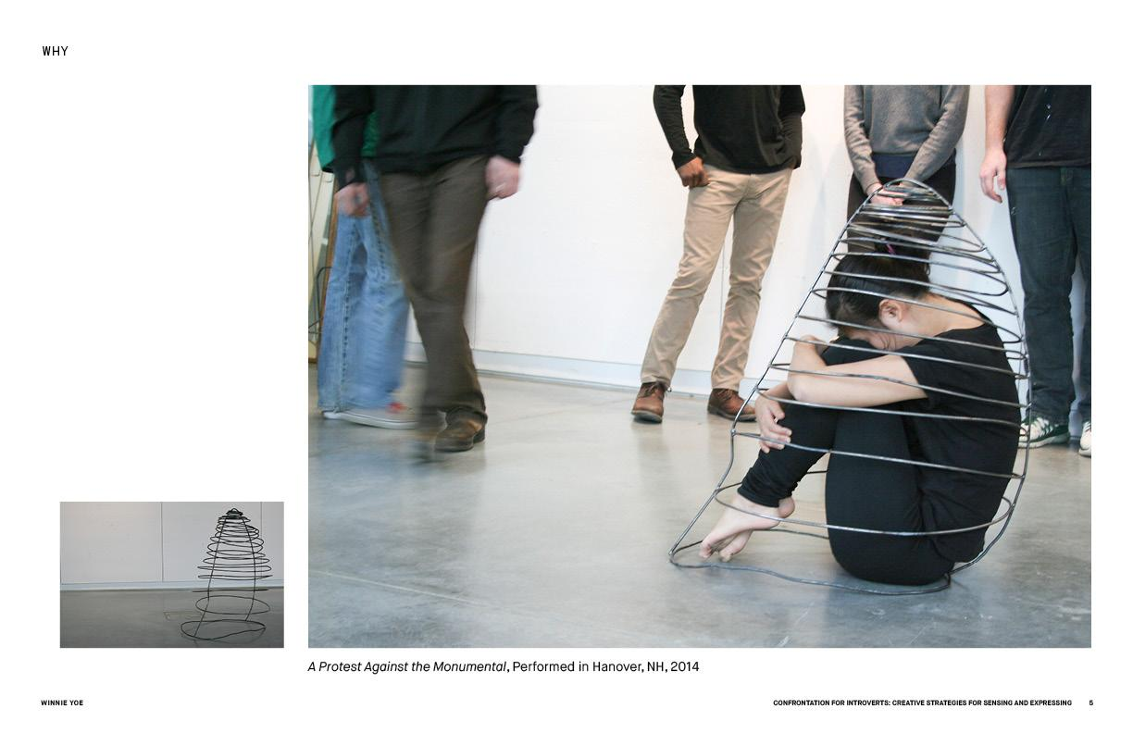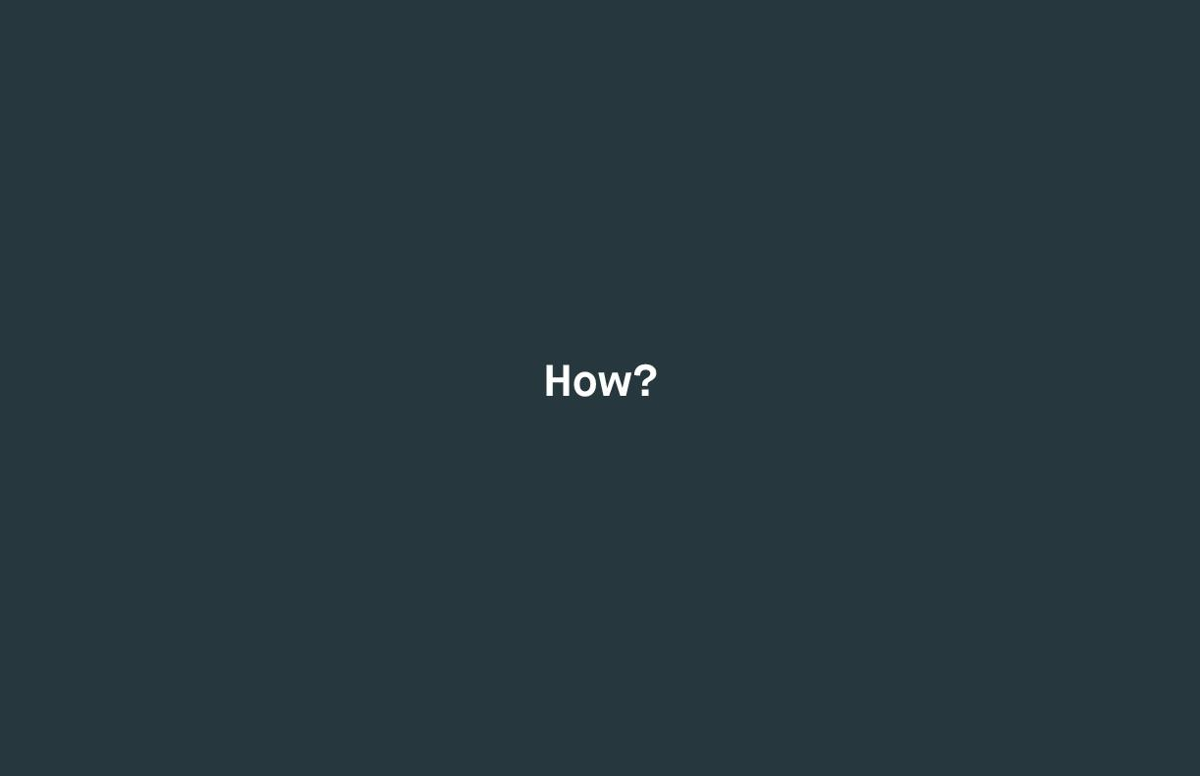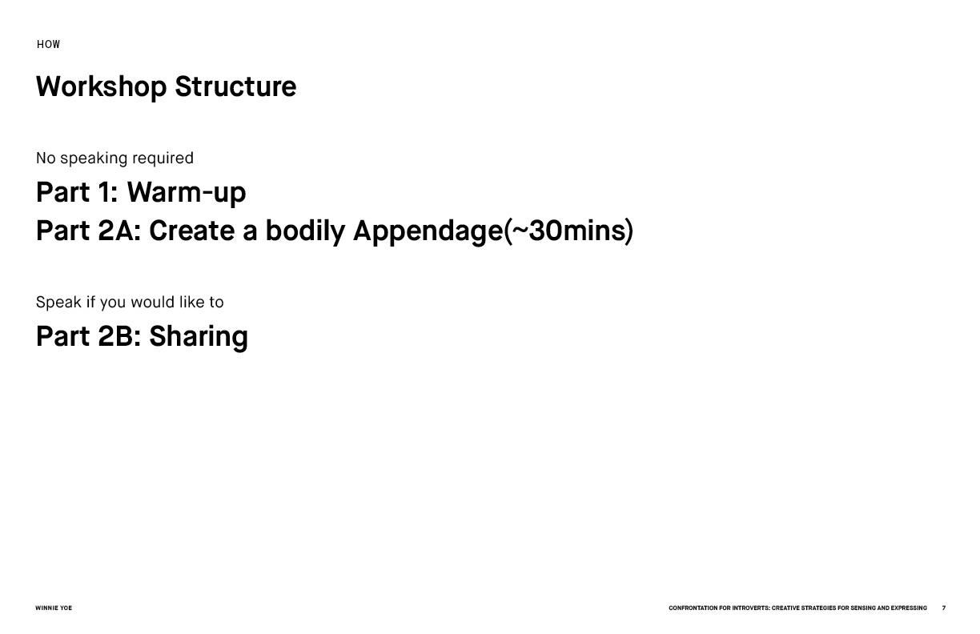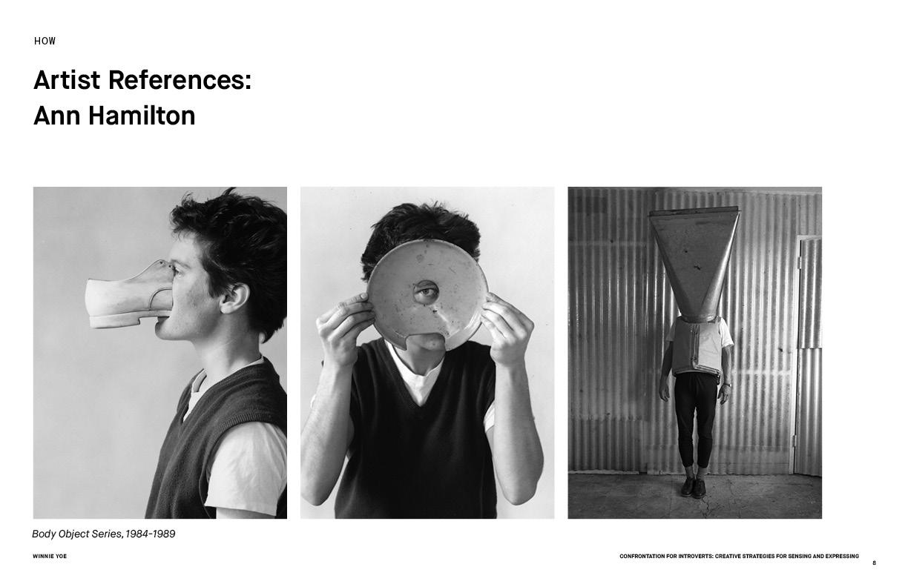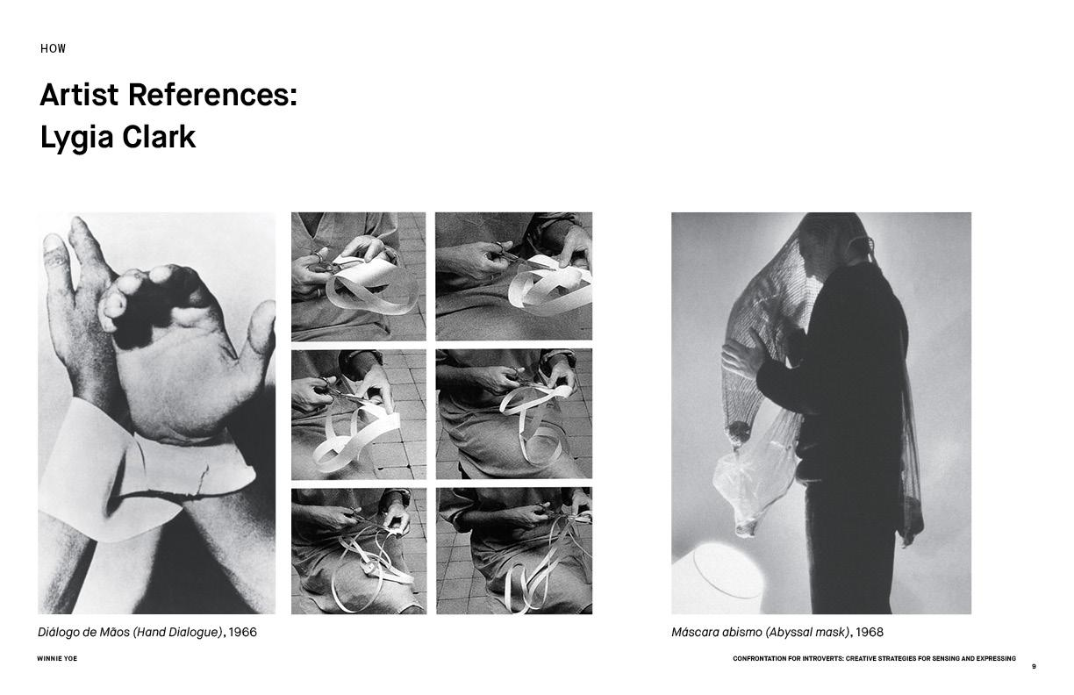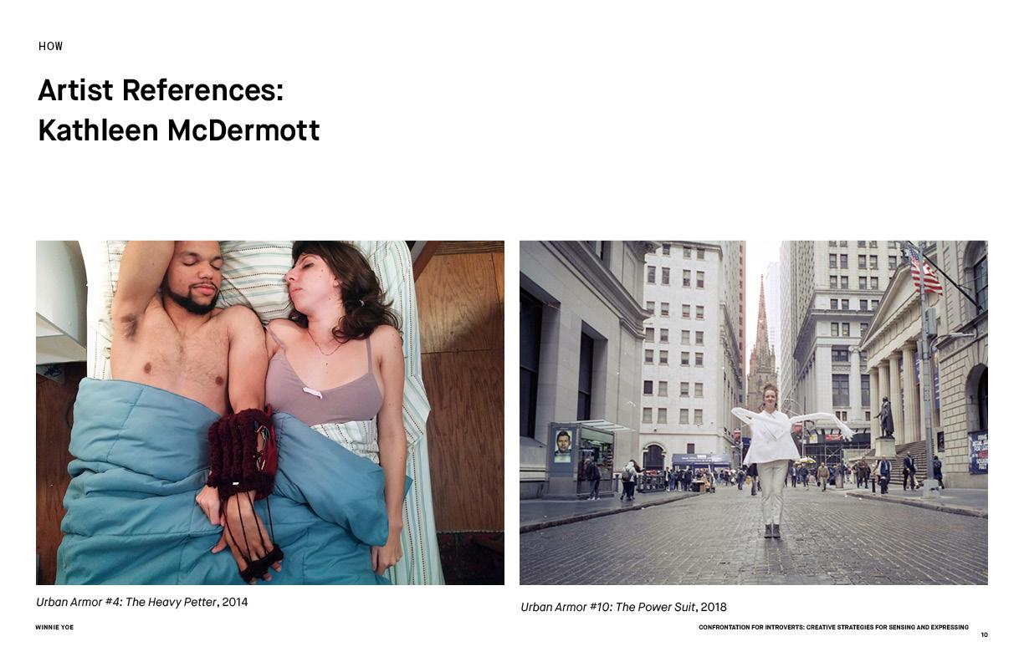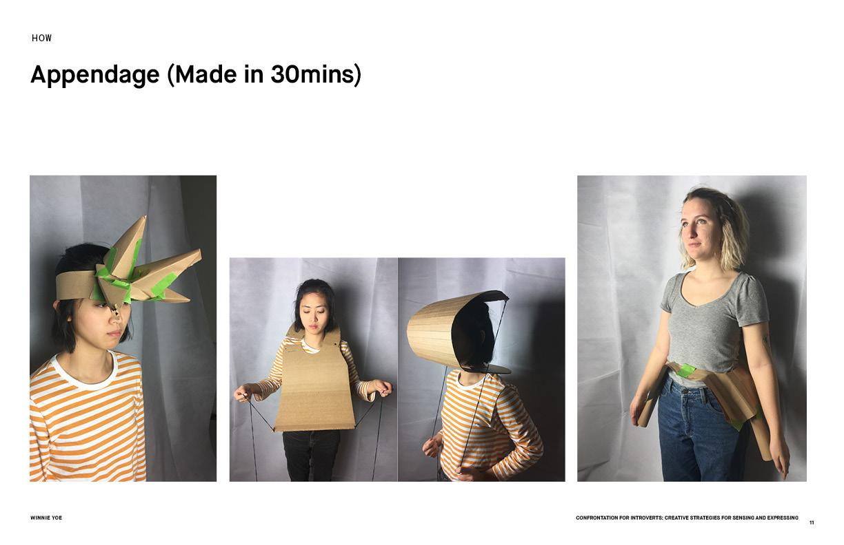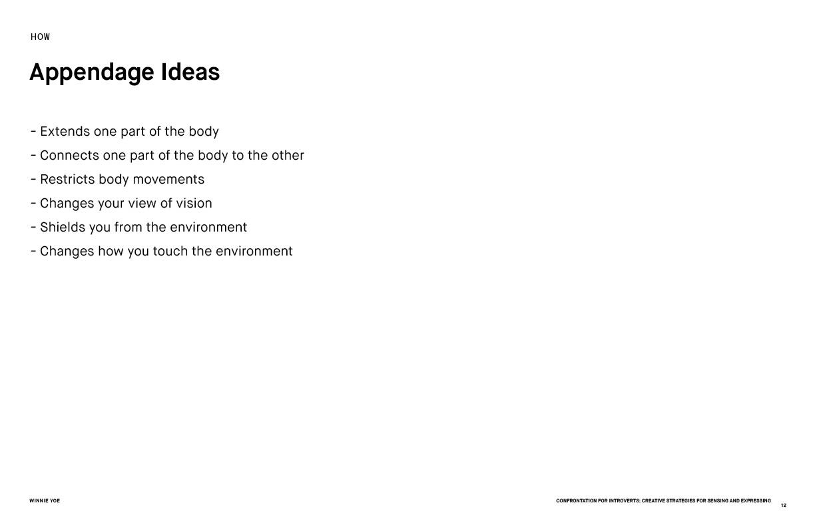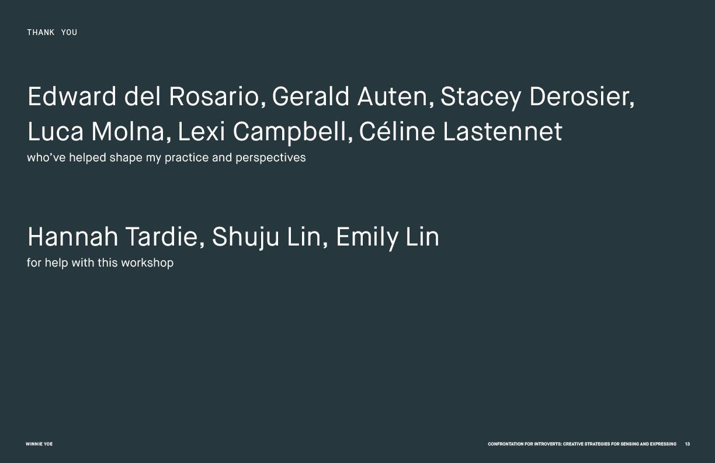

**Appendix II: Leaflet**

Provides participants with other creative strategies for expression and other artist references.

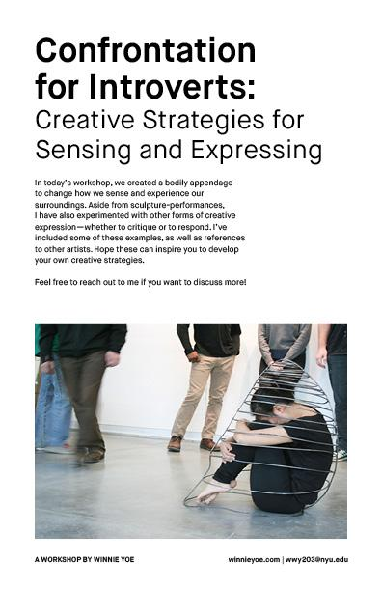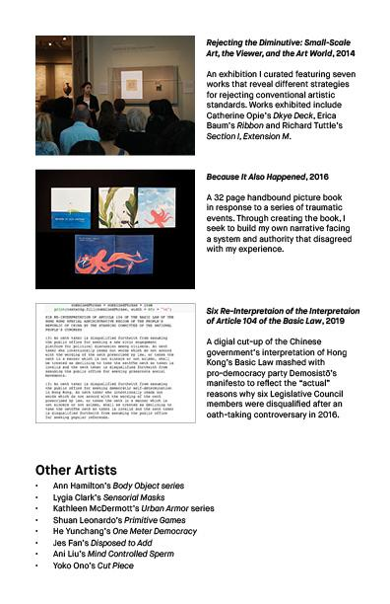

**Appendix III: Event Documentation**

